Pictures
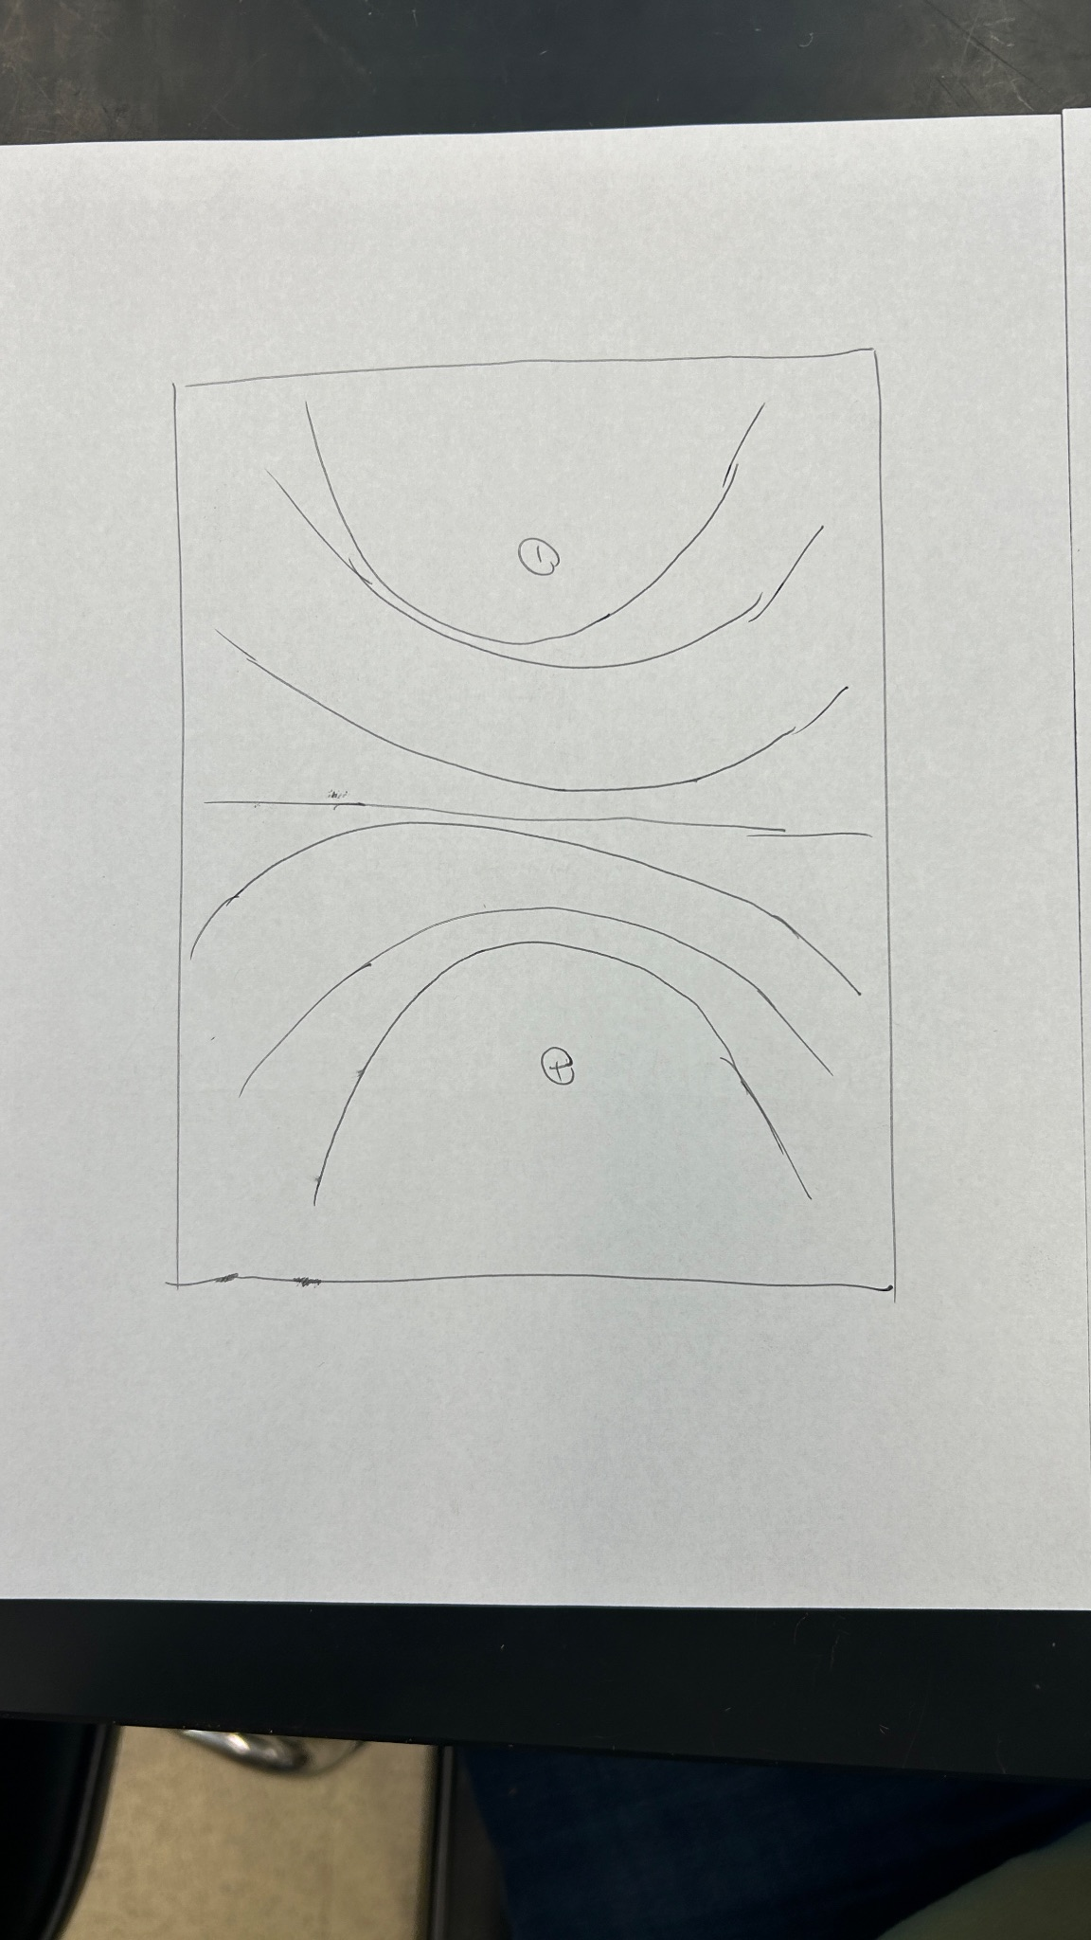
Image 1: Part A, equipotential lines
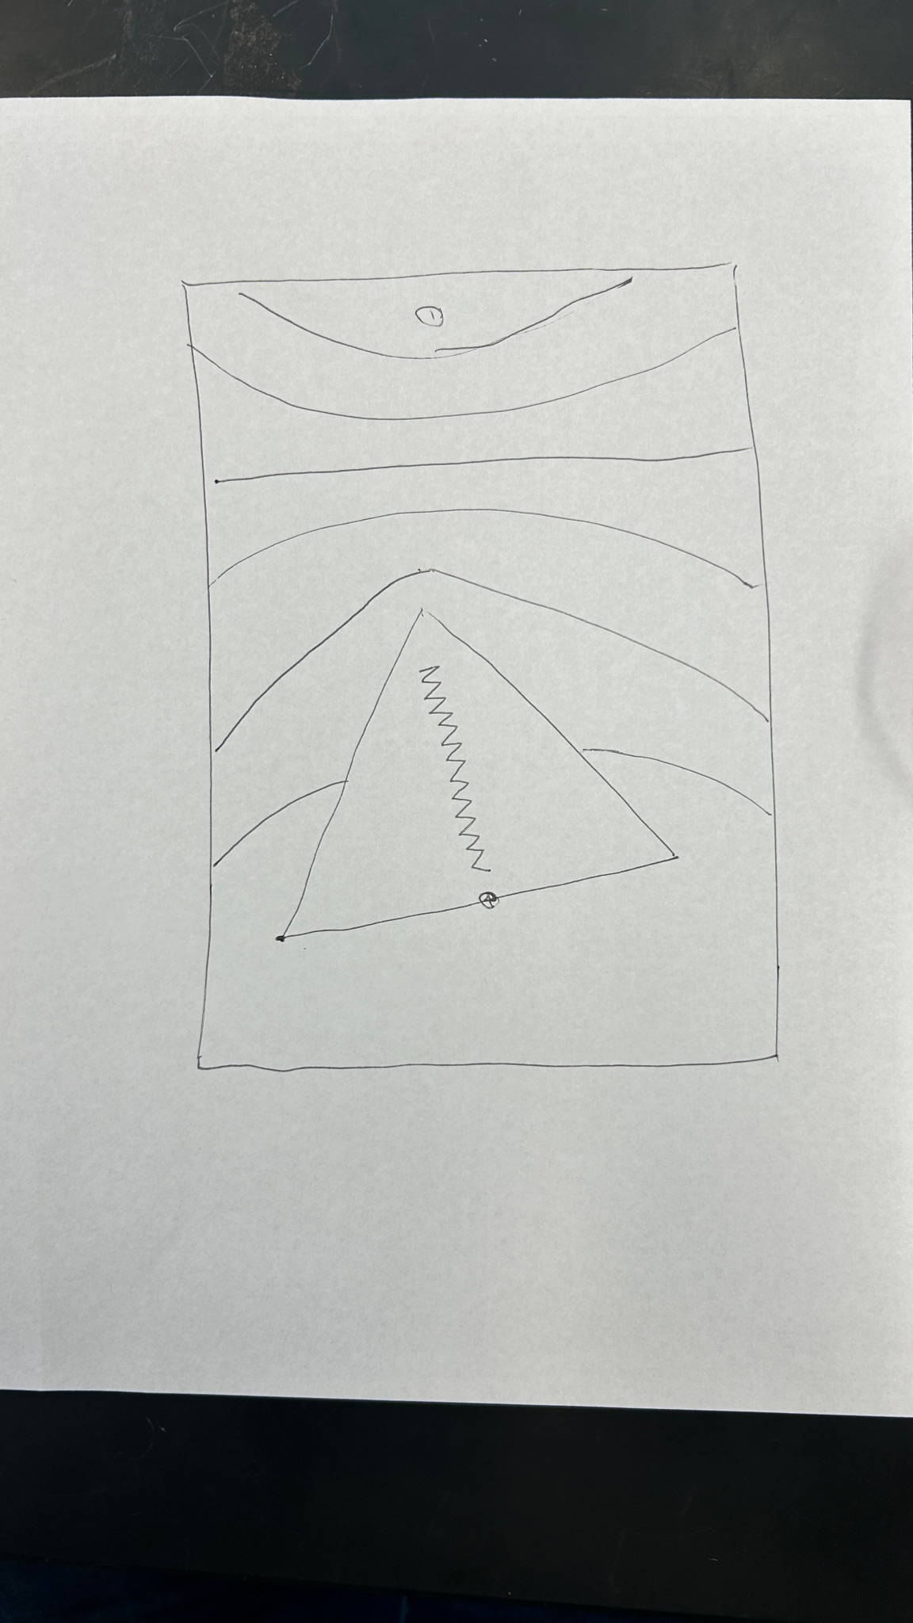
Image 2: Part A, equipotential lines with conductive triangle
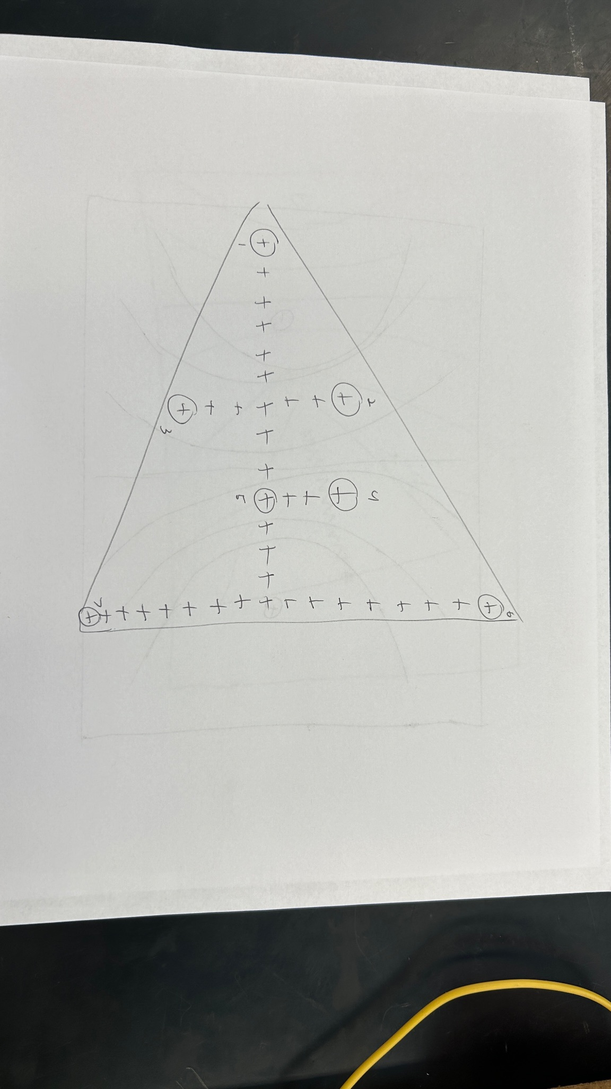
Image 3: Part B, seven points on triangle

Table of Triangle Data
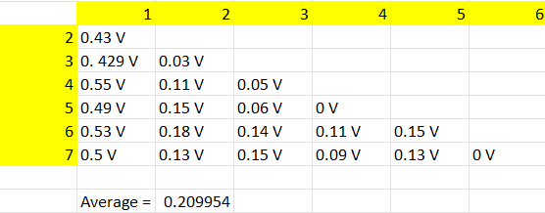

Research Question

The average voltage inside the triangle is not zero. For points the same (or similar) lateral distance from the electrode, the voltage is almost zero, but for points that are laterally very different, the voltage is not zero. To find this, we took seven points within the triangle and measured the voltage from that point to all other points. This gave us a map of voltages that we could average out.

